

*“I am able to do all things through Him who strengthens me” Phillippians 4:13*

**SEN Information Report**

**2021-2022**

*Every Teacher is responsible and accountable for the progress and development of the pupils in their class, including where pupils access support from teaching assistants or specialist staff.*

*This report has been written in accordance with the requirements set out in schedule 1 of The Special Educational Needs and Disabilities (SEND) Regulations 2014 and paragraphs 6.79-6.81 of the SEND Code of Practice (DfE/DoH 2015)*

**Contents Page**

|  |  |
| --- | --- |
| Meet the SEN Team | 2 |
| Types of SEN at Teynham | 3 |
| Mainstream Core Standards | 4 |
| Identification of SEN | 5 |
| Teaching SEN | 6 |
| Training | 7 |
| Parent Voice | 8 |
| Pupil Voice | 9 |
| Training | 10 |
| External Agencies | 11 |
| Local Offer | 12 |
| Transition | 13 |
| Complaints | 14 |

**SEN Team**

**SENCO**

Mrs McIntosh is our Special Educational Needs Coordinator. Mrs McIntosh is responsible for ensuring that pupils receive the correct support, liaise with outside agencies and provides support and advice to teachers and parents where required.

She can be contacted on 01795 521217 or by e-mail - [senco@teynham.kent.sch.uk](mailto:senco@teynham.kent.sch.uk)

Mrs McIntosh works on Tuesdays, Wednesdays and Thursdays.

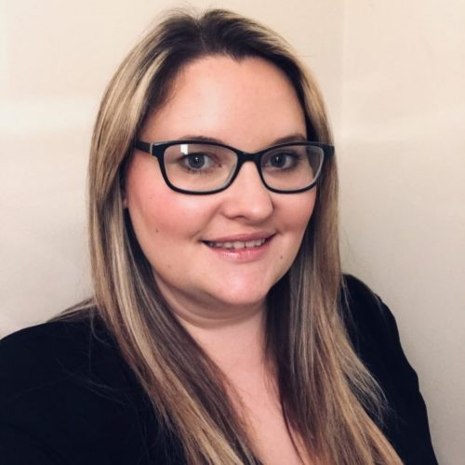



**SENTA**

Mrs Pollard is our SENTA. She works with Speech and Language Therapists and implements and oversees most SALT provision in school.

She can be contacted on 01795 521217 or by email - [e.pollard@Teynham.kent.sch.uk](mailto:e.pollard@Teynham.kent.sch.uk)

Mrs Pollard works 4 days a week, Monday – Thursday.



**SEN Governor**

Mr Lillicrap is our SEN Governor. He ensures that the SEN provision within the school is catered for and monitors all aspects of SEN within the school.

He can be contacted by email – [s.lillicrap@teynham.kent.sch.uk](mailto:s.lillicrap@teynham.kent.sch.uk)

**Speech and Language Therapist**

Mr Green is our Speech and Language Therapist. He comes into school once a fortnight to assess/work with pupils with communication and interaction needs.

He can be contacted via Mrs McIntosh.

**Types of SEN**

Teynham school is a mainstream primary and provides support for pupils with a wide range of special educational needs, including those with:

**Communication and Interaction needs** **(CI)** - this includes students who have speech, language and communication difficulties, and slower processing difficulties and includes students with autism spectrum conditions;

**Cognition and Learning needs (CL)** - this includes students who have learning difficulties and specific learning difficulties, for example dyslexia, dyspraxia and dyscalculia;

**Social, Emotional and Mental Health needs (SEMH) -** for example; Attention Deficit Hyperactivity Disorder (ADHD) and emotional regulation difficulties.

**Sensory and/or Physical needs (SP)** - this includes students who have visual or hearing needs, or a physical disability that affects their learning.

These SEND categories above are definitions of Special Educational Need outlined in the SEND Code of Practice (DfE/DoH 2015).

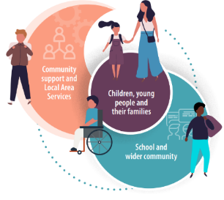

**Mainstream Core Standards**

The Mainstream Core Standards are provisions that the local area expects to be made available for children and young people with Special Educational Needs and/or disabilities attending mainstream schools and guidance for schools, parent/carers and professionals working with children and young people.

A parent guide to the Mainstream Core Standards can be found using the link below.

[Mainstream Core Standards (kelsi.org.uk)](https://www.kelsi.org.uk/__data/assets/pdf_file/0005/117257/Special-educational-needs-mainstream-core-standards-guide-for-parents.pdf)



**Identification of SEN**

Our aim is to identify need at the earliest point, making effective provision to improve long-term outcomes for the pupil. At Teynham, all members of staff monitor the progress of pupils regularly using a graduated approach of assess, plan, do and review. Pupil Progress Meetings, which include the senior leadership team and a Governor, are completed three times a year as well as on-going assessment from Class Teachers. In addition to this, we work closely with parents to identify SEN as early as possible. Class teachers will make regular assessments of progress for all pupils and identify those whose progress:

* Is significantly slower than that of their peers starting from the same baseline
* Fails to match or better the child’s previous rate of progress
* Fails to close the attainment gap between the child and their peers
* Widens the attainment gap

Pupils who are not making expected progress are highlighted and provision is put in place.

Some pupils may continue to make inadequate progress, despite quality first teaching targeted at their areas of weakness and additional provision. For these pupils, and in consultation with parents, we will use a range assessment tools to determine the cause of the learning difficulty.

It may also be necessary at this time to seek advice from external agencies such as Community Paediatricians, Specialist Teachers or Speech and Language therapists. The SENCO will be able to make a referral to external agencies for further investigation.

**Teaching SEN Pupils**

All our pupils have the right to an education which is appropriate to them as individuals. It is our aim to minimise the difficulties which pupils will experience. We aim to achieve this by adapting our curriculum to suit individual needs, provide a range of teaching styles on a variety od scales for example small group work or 1:1 work with an adult, teach strategies to help pupils access the learning and ensure that all learning environments are happy, safe and accessible.

**In addition to this we also:**

* Listen to pupil opinions
* Recognise, celebrate and reward progress, however small
* Be consistent and fair to all pupils
* Enable pupils to make choices and decisions about their work so they feel valued
* Encourage good relationships with pupils and recognise that mutual respect and trust are important

**Parent Voice**

Parents will be contacted if there are concerns with their child’s progress or well-being. This will normally be from the Class Teacher or SENCO. At this point a plan will be made in agreement with the parents for future provision and a review date will be set.

Once reviewed, if a pupil is set to enter the SEN register or need further investigation or provision, parents will be called by the SENCO and invited in for a meeting.

Throughout the school year parents are invited to two parents’ evenings, will have two written reports and if a child has a personalised plan, will have meetings throughout the year with the SENCO.

We encourage parents to raise concerns with the Class Teacher or SENCO in order to aid early identify of SEN.

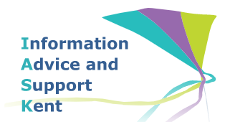

Information, Advice and Support Kent (IASK) provides free, impartial, confidential, advice, support and options around educational issues for parents who have children with special educational needs or disabilities (0-19). They empower parents to play an active and informed role in their child’s education. They can be contacted on: Helpline: 03000 41 3000. Monday to Friday, 9am - 5pm. Email: iask@kent.gov.uk Address: Shepway Centre, Oxford Road, Maidstone, ME15 8AW Telephone: 03000 412 412 Facebook: IASK on Facebook

**https://www.iask.org.uk/**



**Pupil Voice**

We encourage pupils to be actively engaged in their learning and promote independence. We used Growth Mindset and follow a Teach, Practice, Apply strategy using prior learning activities to engage pupils in their learning before continuing with their learning at a level that is appropriate for them to be successful. This strategy promotes resilience, independence and pupils feel valued.

Often pupils are invited to attend meetings regarding their provision. If appropriate, pupils are given the choice over which strategies we trial and review the strategies/provision with the adults. As a result, children are aware that we work in partnership with their parent/carers and see how working together and listening to all involved helps them.

**Training**

All of our staff are monitored and supported by our SENCO ensuring high quality interventions are delivered consistently. In addition to this, some of our staff have the following training;

* ADHD
* Emotional First Aider
* Sounds~Write
* Clever Fingers
* LEGO intervention
* Friendship Skills
* Bucket Club
* Communicate in Print
* Language for Learning
* Language and Speech Link
* Irlens
* Makaton
* Dyslexia
* ASD



**External Agencies**

Mrs McIntosh engages with external agencies in order to support pupils with SEN or seek a diagnosis. We have a very successful record of working with external agencies ensuring pupils get the appropriate support.

Below are some of the External Agencies that we are in frequent communication with;

* Specialist Teacher Service, where a child has been taken to LIFT (Local Inclusion Forum Team) in order to access the correct provision for their learning needs. [MIDAS-Parent-Brochure-2021-2022-1.pdf (teynham.kent.sch.uk)](https://www.teynham.kent.sch.uk/wp-content/uploads/2021/09/MIDAS-Parent-Brochure-2021-2022-1.pdf)
* Educational psychologist
* Speech and Language
* Occupational Therapy
* Community Paediatricians
* The Local Authority [Special educational needs and disabilities (SEND) - Kent County Council](https://www.kent.gov.uk/education-and-children/special-educational-needs)



**The Local Offer**

There are a wide variety of sources of information for parents available online. This includes the ‘local offer’ for Kent which will give you a great deal of information regarding the services available locally.

The Local Offer:  <http://www.kent.gov.uk/education-and-children/special-educational-needs>

The Government guide to SEND for Parents:

<https://www.gov.uk/government/uploads/system/uploads/attachment_data/file/344424/Special_educational_needs_and_disabilites_guide_for_parents_and_carers.pdf>



**Transition**

The SEN team understand that transition can be an anxious time, especially for pupils with SEN and so we are involved in all types of transition.

**Starting School** - Transition meetings start with different Nursery settings in Term 5, earlier if a setting highlights severe needs. If appropriate, we will visit the pupils in their setting or hold additional meetings with the class teacher. The SENCo is present during all transition afternoons to support both pupils and parents.

**Moving between school years** – We hold transition meetings for all pupils with SEN. This includes current and next class teacher and the SENCo. For pupils with complex SEN we encourage contact with parents to support the school transition at home. We also run transition afternoons for all pupils. During these sessions we use a range of strategies including social stories and transition packs to support pupils.

**Leaving Teynham** - We hold transition meetings with the SENCo’s from the secondary schools to outline provision and pupil need. In addition to this, we work with the secondary schools to organise extra transitional visits for vulnerable pupils. For the most vulnerable pupils we organise transition packs and familiar adults to attend transition week with them. These include pictures of the pupils’ new school, key information about them and what to expect.

**Our transition policy can be found on the school website.** [Teynham Parochial](https://www.teynham.kent.sch.uk/wp-content/uploads/2021/06/Transition-policy.pdf)



**Complaints**

In the first instance please talk to your child’s Class Teacher. Contact the SENCO or Headteacher if further information or a conversation is required.

Link to complaints policy <https://primarysite-prod-sorted.s3.amazonaws.com/stgeorgeskent/UploadedDocument/867a70ba0a5a433a84f669c61c926486/complaints.pdf>